**Mr. Visca’s: Calculus (Chpt 3.6)**

**Chpt 3 – Day 10: The Chain Rule**

**3.6 Chain Rule**

Let’s explain it thru something simple... consider: y = 6x - 10, we know that y' = _______

Now...what happens if we factor y? It becomes y = ______________________

we have 2 function: ________________________

let’s now say, y = _______ where _______________________

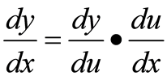

Chain rule says:

Ex 1. An object moves along the x-axis so that its Ex 2. Differentiate sin(x2+x)

position at any time, t ≥ 0, is given by x(t) = cos(t2+1).

Find the velocity of the object as a function of t.

**Repeating the Chain Rule:** (A Three Link "Chain")

Ex 3. Find the derivative of g(t) = tan(5 - sin2t)

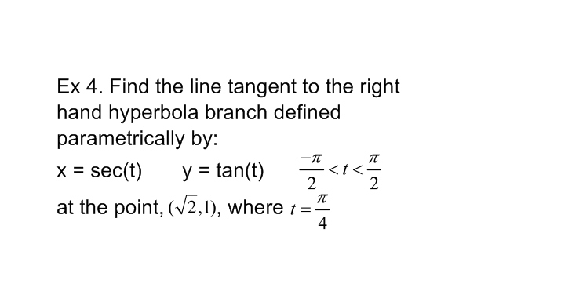

**Finding dy/dx Parametrically:**

Basically:

**Power Chain Rule:**

Ex 5. find f'(x) if f(x) = (3x2 + 2)3

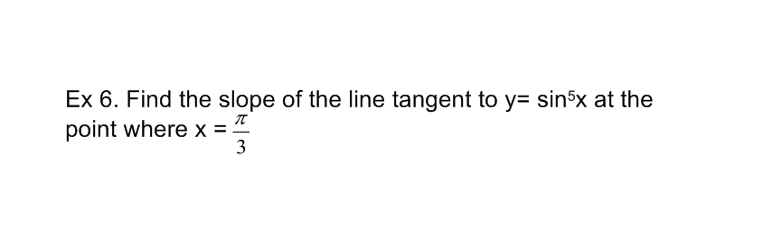

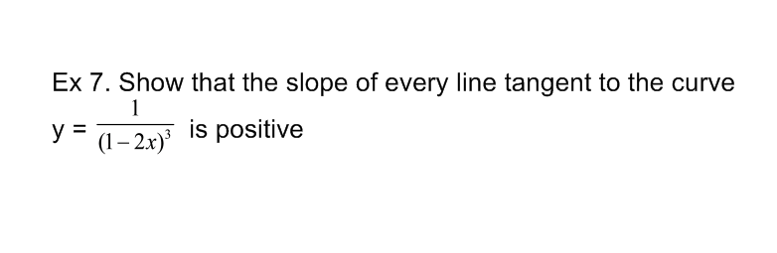

HW: section 3.6

Page 153 (1-19 odd, 42,26)